

EVS guide

for volunteers
of
HODINA H

Introduction
Hodina H
The local community
Practical arrangement for the EVS volunteers
Division of Community grant
Travel arrangement
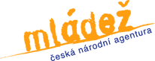



Dear volunteers, dear sending organisations,

Thank you very much for your interest to participate, contribute and cooperate with Hodina H!
Please read the information bellow in this guide where you can find many useful information about EVS, Czech Republic, Pelhřimov and other opportunities.
Please, do not hesitate to contact us with any of your questions!

Hosting organisation: Hodina H
Website: www.hodinah.cz
E-mail: hodinah@hodinah.cz
Phone: +420 602 864 837
Address: Hrnčířská 111, Pelhřimov, 393 01, Czech Republic

See you soon!

Your Team of Hodina H

HODINA H
First purpose of founding “Hodina H” was to establish a Youth Information centre. This could be realized as an organisation itself or as a part of an organisation providing also other activities. Initially Hodina H was just a Youth Information Centre Hodina H but soon other activities and projects were snowballing.

Mission
Mission of the Hodina H is to get, elaborate and provide information first of all to children and young people, to ensure in this way their right of having information, support permanent and sustainable learning and personal development, full-valued leisure time spending, to develop international cooperation, voluntarism, active participation of children, young people and general public in the public happening, to assist and facilitate the citizens´ education. Special emphasis is put on the services for children, young people and young people with fewer opportunities. The seniors – elderly people-, parents with children and general public are not missed out.

Motto
Stop-Think-Go!

Aim and objectives
Our main aim is to increase the quality and support sustainable development of the children, young people competence and local community.

Objectives
- providing and implementing non-formal learning
- offering information and information services to young people
- creating and supporting the possibilities of quality leisure time
- opening a „public space“ for intergeneration, inter – sectoral dialogue and synergy for the quality of the community life
- enriching the cultural life – organize the traditional events
- supporting youth initiatives, projects and ideas
- .....

Hodina H operates as a Youth Information Centre and a Centre of non-formal education (seminars, workshops, debates, forums, conversations, etc.). Additionally we organize Leisure time Clubs. We are coordinating the Youth Parliament in Pelhřimov. We are hosting, sending and coordinating organisation of youth exchanges, EVS and other international projects beside many other activities for different target groups.
Priorities
Hodina H defined its 4 key priorities:
- Information (Youth Information, Eurodesk, presentation, processing information)
- Non-formal education and learning (professional and interest)
- Volunteering (long term volunteering, EVS, community development)
- International cooperation
- Personal development

Important part of Hodina H activities are traditional events:
Dancing region, “Pumpkining”, Chocolate Hour, Non-traidtional race, Neighbours’ day, “Buttoning”

The strucutre of activities of HODINA H:
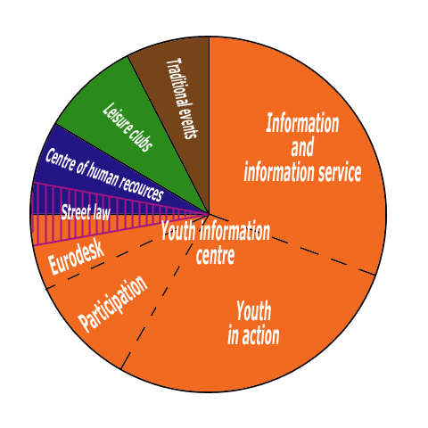

Within the frame of Erasmus+ Programme Hodina H is hosting, sending and coordinating for the following kind of projects: youth exchanges, youth initiatives, European voluntary service, trainnig courses, seminars, etc.
Hodina H is an initiative for coordinating youth participation in Vysočina region, suporting active young people and their participation in local community, creating space for them to act, influence and participate in decision making processes within youth field and assuring an open dialogue among decionmakers in youth policy and field and young people.
In our Leisure time clubs we offer dancing, creative activities, conversations in foreign languages and exchanging experience.
A very important project of Hodina H is the Centre of non-formal education. This project was supported from European Structural funds and State budget and enable organisation of training courses, seminars, debates, workshops, facilities for volunteers and EVS volunteers, it creates conditions for partnership development among NGOs in Vysočina region and Czech Republic.

WHAT? Information, support, leisure time activities, learning

HOW? Actively, interactively, enjoyably, dynamically

WHERE? Europe, Czech Republic, Vysočina region, Pelhřimov
Centre of non-formal learning and Youth Information Centre

WHEN? 365 days per year

WHO? Children, young people, general public and specific target groups

ADVICE, SUPPORT, LEISURE TIME
WITH US ALWAYS YOU FEEL FINE!
EVS in HODINA H

Your Project is focused on working with young people in the local community, also with young people with fewer opportunities (mainly due to social, economical reasons and at risk). In general your project is focused on the youth work, leisure time activities for youth, information for youth, work with non-organised youngsters, their motivation of involvement and participation. Last but not least your project includes main issue of intercultural understanding, respect, diversity and further European topics.
Main elements of the project are: public happening, life in the local community, youth information and working with them, activating young people and motivating them to various opportunities they have.
We see EVS is about how to promote European values, cultures and active attitudes of young people to take part in the building process of Europe, European culture, mutual understanding and cultural diversity made by real personal experience.
Our association Hodina H believes and has experience "a living example is the best example" - to follow, learn and lead others to develop, open themselves, participate and be an active citizen.
Our motivation is coming from the will to influence the minds and opinion of people about foreigners and different cultures.
Our activities are orientated towards tolerance, interculturality, multiculturality, non-formal education involving learning foreign languages, a general overview and uptodated information.
The EVS volunteer will enrich our activities, bring new ideas and confirm the tolerance and multiculturality of our aim. The volunteer will contribute to extension of our activities. They will make our activities more attractively attracting young people, increasing the interest in our activities (other education - nonformal, motivation to improve their skills and to know about the opportunities of the EVS, etc.), show then the possibilities to participate in society’s life and events. They will organise open activities with the main aim - to break the barriers among the people to show that people look, wear and think in different ways but anyway they can live next to each other with understand-ment, not to fight or close their minds.

Coordination activities:
We are coordinating individual and group EVS: 3 volunteers in Hodina H and 2 other volunteers in Fokus Vysocina, organisation where Hodina H coordinate the EVS project. The volunteers of Fokus are still involved also in activities in Hodina H (around 4 hours/week and according to their interest in the traditional events).
The accommodation for this year will be changed and volunteers will live in the flats (2 – 3 volunteers in one flat). Flats are being arranged during September. Otherwise there is still possibility of stay in the dormitory.
All Hodina H volunteers are living together in a dormitory and they will work together in the same organisation in the different activities and event especially according to the interest, abilities and motivation to learn. The cooperation and common moments of all 3 three volunteers will be organized for the planning and evaluation, common activities/big events, reflection. However the role of the volunteer is not initially fixed but develops during their stay.
The biggest benefit is that volunteers will stay together; during their stay far away from home supporting in each other. Additionally there will be your hosting organisation and mentors so you won’t be alone.
EVS volunteers are treated as full members of the hosting organisation Association Hodina H. The preparation and common planning is starting before EVS volunteers´ arrivals. For the whole duration of EVS it is essential all actors of EVS cooperate and communicate mutualy.
Structure of activities of „Be ready“:
- Working in the Youth Information Centre: 60%
- Assistance and support for international projects: 10 %
- Leisure time activities: 10 %
- Presentation and promotion of EVS, YiA Programme and other non-formal learning activities: 20 %
- Participation in the traditional events, cultural and sport events
Structure of activities of „Come as you are“:
- Mobile youth work – work with children and young people: 50%
- Assistance and support for international projects: 10 %
- Leisure time activities: 10%
- Local events - organisation: 20 %
- Non-formal learning activities and administration work: 10 %
Structure of activities of „Fokus“:

- Sheltered workshop: 30%
- Volunteering centre: 30 %
- Language activities and organisation support: 30%
- Leisure time activities: 10%

Time schedule:
- 5 days per week, max. 35 hours per week
- example of schedule of work from 9:30 – 17:30 (including the lunch break) but time schedule can be flexible according to your interest, particular program and activities which can be moved to evenings or weekends (up to the common agreement between volunteer and Hodina H)
- time schedule can be adapted according to activities in the mobile youth work – time schedule of cooperating partners´ organizations as the agreement with the volunteer as well.
Every EVS volunteer will be supported by Hodina H and their mentors in the adaptation phase, getting to know everything and becoming involved in the local community, also beside their EVS projects, meeting new people, making friends and acclimatization. Furthermore everybody will try to create a friendly atmosphere so that you will feel comfortable and nice here.

Draft of the activities (always finalized with the volunteers to be in line with their needs, competences and interest)

HODINA H:
- processing the inforations for young people as part of the Youth Information Centre
- leisure time activities
- language activities in Hodina H and partners (Pacov)
- presentation and workshops for young people
- organisation of the events
- project of international cooperation

2014 (draft general main activities):
- volunteer from UK (6 month): language support in the Primary school (Pacov), activities in Hodina H
- volunteer from Malta (10 months): language activities in the Kindergarten (Pacov), activities in Hodina H
- 2 volunteers (France, Spain - 10 months): activities in Youth Information centre, Hodina H, Kindergarten (Dubovice) and cooperation with schools, activities in Hodina H

FOKUS Vysočina:
- activities and assistance in the Primary school in Humpolec
- language conversations for the volunteers and children from social low and risk background
- social theraphy workshops
- creative club in the Pelhřimov hospital
- administrative work/office
- activities with partners as member of the volunteering centre
- events

Youthpass (Tool .which started during the Youth in Action Programme and will go on in Erasmus+ due to that is mentioned Youth in Action)
Youthpass is part of the European Commission’s strategy to foster the recognition of non-formal learning. Youthpass is a tool for participants of projects funded by the Youth in Action Programme to describe what they have done and to show what they have learnt.
Youthpass Certificates are available for European Voluntary Service, and are based on the reflection and self-assesment process of the learning during the whole EVS.
Creating their Youthpass Certificate together with a supportive person, participants of “Youth in Action” projects have the possibility to describe what they have done in their projects and which competences they have acquired. Thus, Youthpass supports the reflection upon the personal non-formal learning process.
Documenting the added value of a “Youth in Action” project, Youthpass visualises and supports active European citizenship of young people and youth workers.
Being a validation instrument for non-formal learning in the youth field across whole Europe Youthpass contributes to strengthening the social recognition of youth work.
Making visible and validating key competences through a certificate Youthpass finally aims at supporting the employability of young people and youth workers.

YOUTHPASS IS  | YOUTHPASS IS NOT 
A confirmation of participation by the organisers of a specific activity | Something which gives any rights to the holder
A description of the activity | A formal accreditation of competences
An individualized description of  - activities undertaken  - learning outcomes | A replacement for any formal qualifications
A certificate for people participating in Youth in Action Program activities | Available to demonstrate learning outcomes from activities undertaken in the YOUTH programme (which  came to an end in 2006)
A tool which puts the Key competences for Lifelong Learning into practice | Just a certificates
Firmly based on principles of non-formal education and learning
Supported by the Youth in Action Programme of the European Commission
An explanation of Youth in Action Programs activities which can be understood by people outside the youth field
A way of improving visibility of learning in the Youth in Action Programme

PRACTICLE ARRANGEMENTS FOR VOLUNTEERS

Lodging:
Volunteers are accommodated in the dormitory of the vocational training school of Pelhřimov by the hosting organisation Hodina H/flats (2 -3 volunteers as mentioned above).
Each volunteer will have a separated room with bathroom and toilette (the bathroom and toilette are shared always for 2 rooms, 2 volunteers). The volunteers share the kitchen and the common room. The accommodation is a 10 min walk away from the organisation where will be run most of the activities. The lodging of friends and family, etc. will not be admitted without the agreement of the EVS coordinator or president of Hodina H. Additionally, there might be a fee fixed by the dormitory. Hodina H (president, EVS coordinator) and coordinator of the dormitory are responsible for this decision. Only short-term visits will be admitted (max. 2 - 3 days) in case of no fee. Hodina H has legal authority of expelling any unknown person from the dormitory/room of the volunteer always when the volunteers have not brought to light their stay.
The rules related to the rooms and dormitory will be clearly explained after the arrival of the volunteers.
The rooms are equipped by the table lamp, sheets, pillow, blanket and in the kitchen is all equipment for the cooking.

Photos of the dormitory (consider these photos only as examples of the rooms, common room and the kitchen):
http://www.spssou-pe.cz/foto-video/fotogalerie/domov-mladeze/
Information about the flats will be send immediately after the final arrangements.
Board:
Volunteers will receive once a month all the alimentation for the menu proposed by themselves. The volunteers are in charged of the preparation of their meals. Lunch during the week can be arranged in the school canteen by hosting organization Hodina H if volunteers want.
The amount of board money per day is about 130 - 150 CZK depending on the meal provided by the hosting organisation also during the activities.
Pocket money:
The volunteer receives 90 € each month. The amount of pocket money is fixed by the rules of European voluntary service as part of the Erasmus+ Programme.
Language:
There are 1 – 2x/week Czech lesson with the teacher in Hodina H.
Here are some useful link for start with Czech:
http://www.czech-in-prague.cz/index/useful_links/0-13
http://www.memrise.com/
http://www.internetpolyglot.com/
https://www.youtube.com/playlist?list=PL140ACA849681345D
http://fsi-language-courses.org/Content.php?page=Czech

The weather:
We have 4 seasons ... so take with you cloths for warm/almost hot summer, snowy cold winter and rain during the year.
More about weather in Czech you can find on http://aktualne.centrum.cz/pocasi/

Internet:
Internet is available in the hosting organization - Youth Information Centre from Monday to Friday and also weekends according to the agreement. Wi-Fi is as well offered in the dormitory from 06.00 to 22.00 (timing for the last year).
Mobil:
The hosting organisation provides a Czech SIM card with a Czech phone number to volunteers. The organisation is able to borrow you a mobile but we would like to ask you to bring your own one so please unblock your mobile phone to use it in Czech Republic.
Contacts – Hodina H:
President Daniela Havlickova and Eva Havlickova
EVS coordinator Iva Havlickova +420 777 129 257, iva@hodinah.cz

More about Hodina H: www.hodinah.cz

More about the EVS in Hodina H:
http://www.hodinah.cz/portfolio/evropska-dobrovolna-sluzba/

TRAVEL ARRANGEMENTS

Travel costs will be reimbursed from the budget of European Voluntary Service project (Erasmus+). There is a limit for each volunteer based on the EVS rules. The reimbursement will be calculated upon the original tickets, boarding passes and invoices that volunteers or the sending organisaiton deliver to Hodina H.
The main airport of Prague (Vaclav Havel) is about a 1,5 hours drive far from Pelhřimov. The arrival of the volunteers will be agredd with Hodina H, volunteers can be collected by Hodina H or arrive to Pelhrimov with full instructions.
Otherwise the best way from the airport is to go by bus. Take the number 119 to the stop DEJVICKA, there you change to metro line A and go to the stop MŮSTEK, there change to line B and go to the metro stop FLORENC, where is the bus station and busses going to Pelhřimov.
Another bus station is in the metro stop ROZTYLY, bus 119 from the airport to DEJVICKA, metro line A to MUZEUM, change to line C and go to stop ROZTYLY.

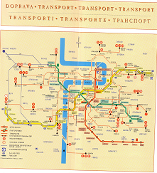
PELHŘIMOV

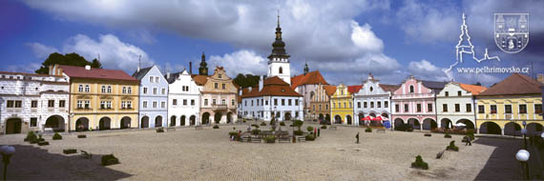

Description:
The town of Pelhřimov is rightfully called “the Gateway to the Highlands“ due to its situation in the westernmost tip of the Czech-Moravian Highlands. Through Pelhřimov run river Bělá. The highest place is Křemešník, which is 767m.
The altitude above sea level at the foot of the tower of the Church of St. Bartholomew is 498.63m and at the railway station it is 509.7m.

Traveling to Pelhřimov:
- The airport in Prague is called Vaclav Havel.
- The picturesque town of Pelhřimov is located approximately half-way between Prague and Brno if driving along the D1 motorway – EXIT 90 near Humpolec.
- Pelhřimov can be easily reached by train (railway line No. 224 from Tábor to Horní Cerekev) or by bus (through services for example from Prague, Brno, České Budějovice, Hradec Králové, Znojmo, Jeseník, …).

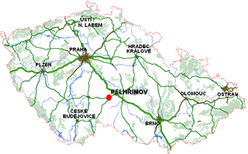

History of the town:

The history of the town goes back to the 12th century. Than the original settlement on the site of what today is the brewery, the Dean’s garden and St. Vitus Church was mentioned for the first time. According to a legend the town was founded in 1225 - 1226 by Pelegrin (Pelhřimov = Pelegrin´s Town) by the Bishop of Prague who made a stop here at the local spring on his journey to Rome. Therefore Pelhřimov bears a figure of a pilgrim in a gate between two towers on its municipal coat-of-arms. At the beginning of the 13th century the original settlement was plundered by Vítek of Hluboká and a new town was founded using a regular ground-plan, which is still preserved in the centre of town. The economic development was favourably influenced by silver mining in the vicinity of the hill of Křemešník. A number of crafts developed here, too, mainly they are drapery, weaving, ginger baking, dyeing and brewing.

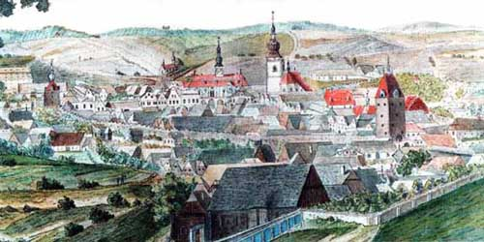
At first Pelhřimov was an Episcopal town, during the period of the Hussite wars the town was administered by Tábor hetmen and after the Battle of Lipany it was gained by Mikuláš Trčka of Lípa. At that time four of the country’s conventions were held here, summoned to settle disputes between the Catholics and the Utraquists. In 1550 the Říčanský family of Říčany became the new lords of Pelhřimov, they had a chateau built here but the town opposed them in long-lasting disputes resulting in exemption from serfdom in 1572. In 1596 Pelhřimov was granted the status of a royal town. That was also a period of extensive building development of the town.
Of vital significance for the town was the development of industry in the 19th century. Pelhřimov became a centre of the brush-making and knitting industries and production of agricultural machinery.

Culture:
Kino Vesmír, town theatre, galerie M, library, KD Máj, trainning-dance, Music club Atlantic, Music bar Sauna

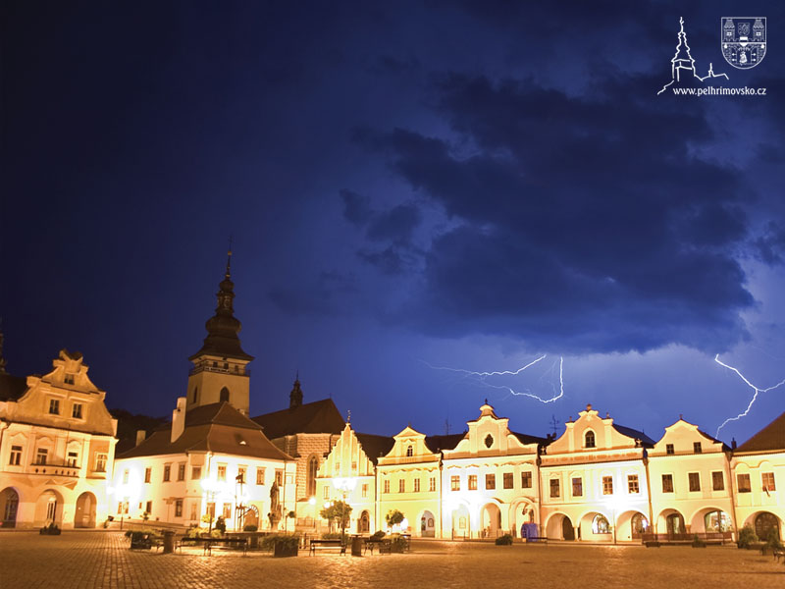

Museums: Musem of Lipský,museum of records and curioties,museum of ghost,museum highlands
Churches: sv.Vít, sv. Bartoloměj, sv.Kříž
Holidays: State Holidays in Czech Republic. The most important are Christmas, Easter and National Holydays Days.
Gastronomy: The Highlands are known for track-gardening potatoes.
Schools: There are 4 basic schools, 5 secondary schools and one special school.
More information about life in Czech Republic: www.czech.cz/en

