PROGETTO ZATTERA BLU - is urgently looking for an evs candidate.
Title of the project: V.I.P. Very Inclusive People
Reference Number of the project: 2014-3-IT03-KA105-004394
Period: 01 OCTOBER OR O2 NOVEMBER 2015 (10 months)
Description of the organization
Adelante is a social cooperative, founded in 2003 in Bassano del Grappa (VI).
Its main aims are the design and realization of social and educational activities for children and young people, with particular attention to minors in social distress. The values that guide our actions are peace, social justice, appreciation of diversity as a resource, solidarity and the centrality of human beings.
Our activities are primarily directed to children, young people and their families (a total of about 1000 people).
For the realization of educational activities can be of great support young volunteers of the European Voluntary Service, providing a stimulus, a new point of view, intercultural people
who do not often have had no chance to get in touch with young people other cultures.

Accreditation number: 2012-IT-102

More information: http://europa.eu/youth/vp/organisation/42001110260_en

Location:
Bassano del Grappa - Province of Vicenza - Veneto region – Italy

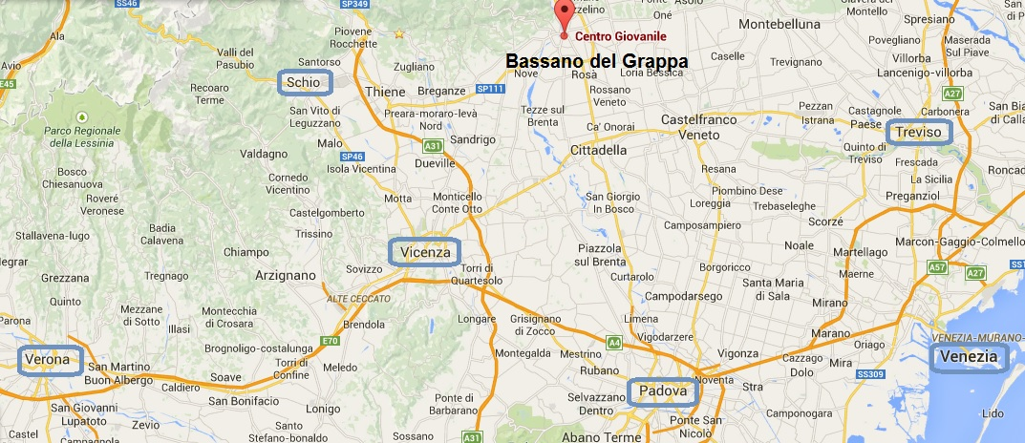

https://goo.gl/maps/vsfUs

Topic:
YOUTH CENTER/YOUTH LEISURE.

Role and tasks:
The volunteer will have the role of:
- increase relational interchange between operators and beneficiaries in a youth centre (target: mainly migrants) resulting in a cross-cultural point of view, which will enrich the work of educators and the activities in respect of minors and youth beneficiaries;
- support educators and territorial animators in projects aimed at promoting the participation and the inclusion of young people with fewer opportunities through activities of non-formal education addressed to minors in a youth centre, also making specific contributions in the proposal and implementation of the activities with particular reference to the activities for the leisure time;
- be witnesses and ambassadors of opportunities for international mobility and voluntary, offered to all young people, to support and planning activities that promote knowledge of the EVS.

PRACTICAL ARRANGEMENTS
- Accommodation: shared flat (for 6 people) in the centre of Bassano del Grappa with others volunteers, young people or youth workers of the cooperative. Double room, shared with another evs volunteer, shared toilet and bathroom. The main room (dining room) is also used for meetings for children 2 times for week but the bedrooms are in a different area of the house. It’s not allowed to host people in the flat
- Meals: in the house
- Transport: the house is near to the city centre (5 minutes on foot). The volunteers will have a bicycle to move
- Italian language course: lessons with a professional italian teacher with over 3 years of EVS volunteer experience + Online Linguistic Support
- Other information: in the Province of Vicenza there are other 20 evs volunteers. Different CO provide initiatives to promote the knowledge between the volunteers

Send cv and motivation letter to: evs@progettozatterablu.it. Object: EVS_VIP_ADELANTE.

