PROGETTO ZATTERA BLU - is looking for an evs volunteer.
Title of the project: V.I.P. Very Inclusive People
Reference Number of the project: 2014-3-IT03-KA105-004394
Period: 01/10/2015 (10 months) or 01/11/2015 for 10 months.
Description of the organization
L’Orsa Maggiore is a cooperative that offers services for the training and employment of disadvantaged people in order to make it possible, after adequate preparation, the transition to normal workplaces (private or public companies). Through the work of the Cooperative "produces" integration, placing the first place people and their needs.
The operators are specialized to assist people with discomfort and disability. For the realization of educational activities with disabled people can be of great support young volunteers of the European Voluntary Service, providing a stimulus, a new point of view, intercultural people who do not often have had no chance to get in touch with young people other cultures.
Accreditation number: 2013-IT-140
More information: http://europa.eu/youth/vp/organisation/42001222296_en
Location:
Malo - Province of Vicenza - Veneto region – Italy
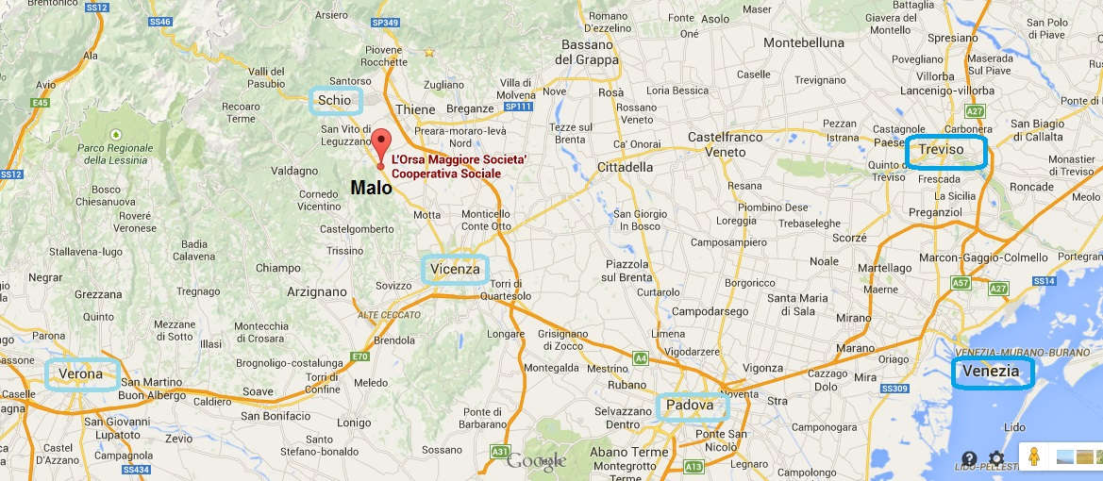
https://goo.gl/maps/1QEXR
Topic:
DISABILITY/SOCIAL INCLUSION
Role and tasks:
The EVS volunteers will provide support to educators in two services:
- The Group apartment for the autonomy of a group of six disabled residents in an apartment of the cooperative;
- Creative workshops and recreational services (preparatory work, called "labs jobs").

PRACTICAL ARRANGEMENTS
- Food: breakfast and dinner in the flat; food is provided by the hosting organization according with the volunteer; lunch in the host organization (restaurant inside).
- Accommodation: In a flat shared with another evs volunteer. Single bedroom. The flat is in the community above another flat that hosts also 6 mentally retarded people (independent; they work in the host organisation). If the host organization needs of this apartment, is possible to be used by them.
- Working hours: 31 hours/week
- Day off: 2 Saturday and Sunday free in a month. If it were agreed activities on Saturday and Sunday the volunteer will have 2 consecutive days of recovery weekly
- Holidays: 9 hours for holiday per months. 5 days free for Christmas period. Other holidays could be discussed with the tutor
- Pocket money: 115 Euros/month, paid every month in cash
- Local transport: The organization provides volunteer a bicycle to reach the town centre in 10 minutes
- Language support: It will be organised an Italian language course for the volunteer with a professional teacher, according with her needs
- Trainings and support: guarantee by the sending, receiving and coordinating organization
- Hosting guests: Lodging people that don’t belong to the project or guests is not permitted. In case someone of your family or your boy/girlfriend or friends would like to visit you, the hosting organisation will try to find a solution
- Insurance: Sending organization is responsible for the volunteer’s insurance (AXA), all the parties are obliged to get acquainted with the insurance rules. The volunteer is responsible of payment of any medical expenses during the evs service and to fill the Healthcare Claim form to get the reimbursement by MSH International/France.
- Other information: in the Province of Vicenza there are other 20 evs volunteers. Different CO provide initiatives to promote the knowledge between the volunteers
Send cv and motivation letter before 25th July to: evs@progettozatterablu.it. Object: EVS_VIP_ORSA.

