We invite you to have a look at amazing EVS project
“Volunteer’s support for special children”
in Russia, Saint-Petersburg.
WHERE?
Saint-Petersburg, Russia
WHEN?
1 September 2018 – 31 August 2019
HOSTING ORGANIZATION?
Host organization’s name is “Shag navstrechu” (Step forward), here’s the web-site https://shag-navstrechu.ru/, FB page is here https://www.facebook.com/ShagNavstrechu.
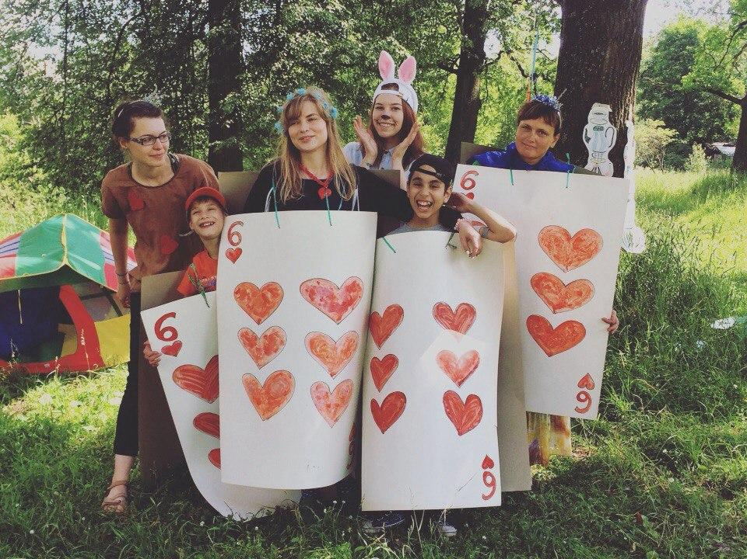
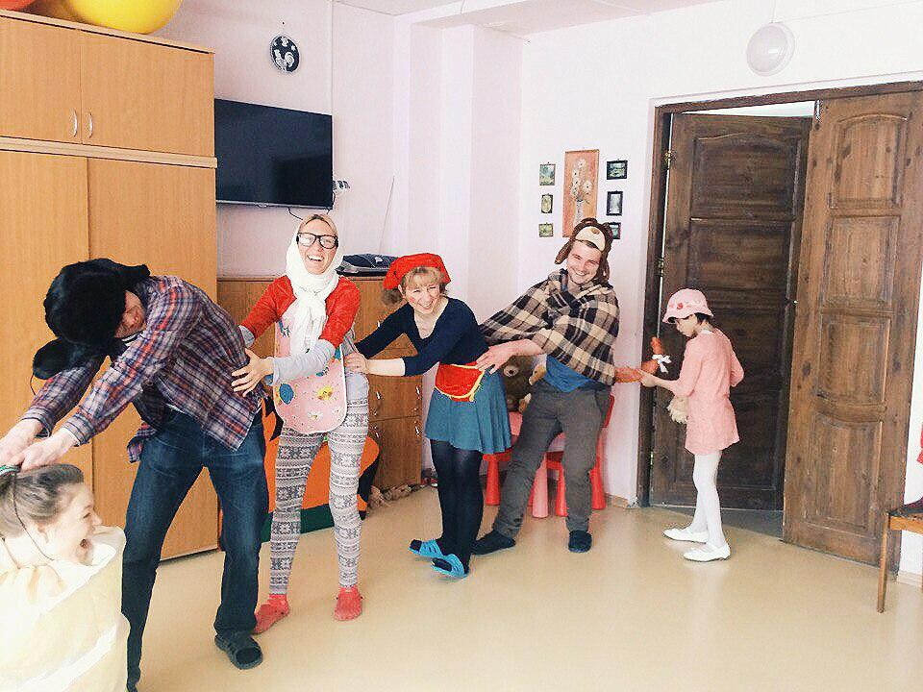
"Shag Navstrechu" was created in 2004 in Saint-Petersburg, Russia to support disabled children (81 boys and girls with multiple disorders in development) who live in the 3rd building of the orphanage №4 in Pavlovsk. Apart from mental disorders many children also have physical ones. The most important things they need are love, care and support, which are given by specialists and volunteers of our organization.
Aims of our organization are:
- social support and care about disabled children from the orphanage №4 (3rd building) in Pavlovsk, St Petersburg,
- assistance in finding families for the orphans,
- help children from the orphanage №4 (3rd building) in emotional, cultural and physical development through organization of regular events.
Our goals are:
Our main goal is to give love and care, to compensate the lack of attention and support for the orphans, who extremely need it and who haven’t any emotional contact with family or relatives.
  - to teach disabled children main self-service skills to be ready for adult life,
  - individual care and support of each of 70 children,
  - mental and physical development through art and music classes, work with physical therapists, everyday classes etc,
  - to make disabled people an equal part of the society,
  - to widen society's knowledge about people with disabilities.
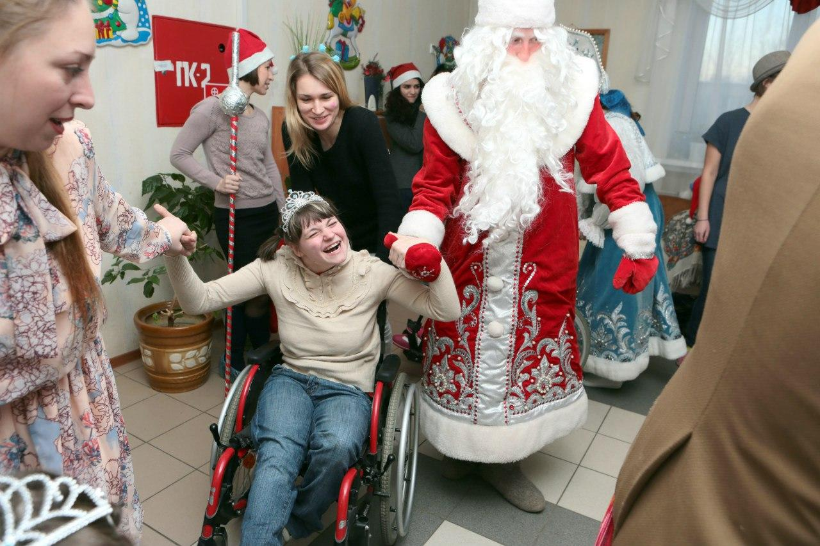
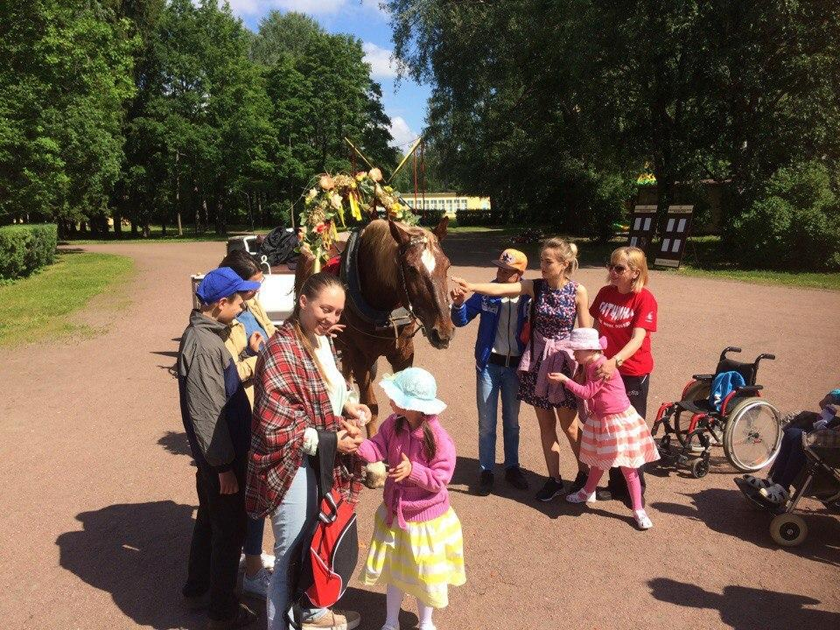

ACTIVITIES OF VOLUNTEER?
The volunteers will hold different ‘routine’ activities for and with the children every day, like playing educational games, drawing, crafting classes, outdoors activities and songs, depending on the volunteer’s interest and fields of expertise and the children’s abilities and skills.
Main activities, which volunteers will do, are:
• teaching kids how to eat, brush teeth, wash, get dressed etc. without assistance,
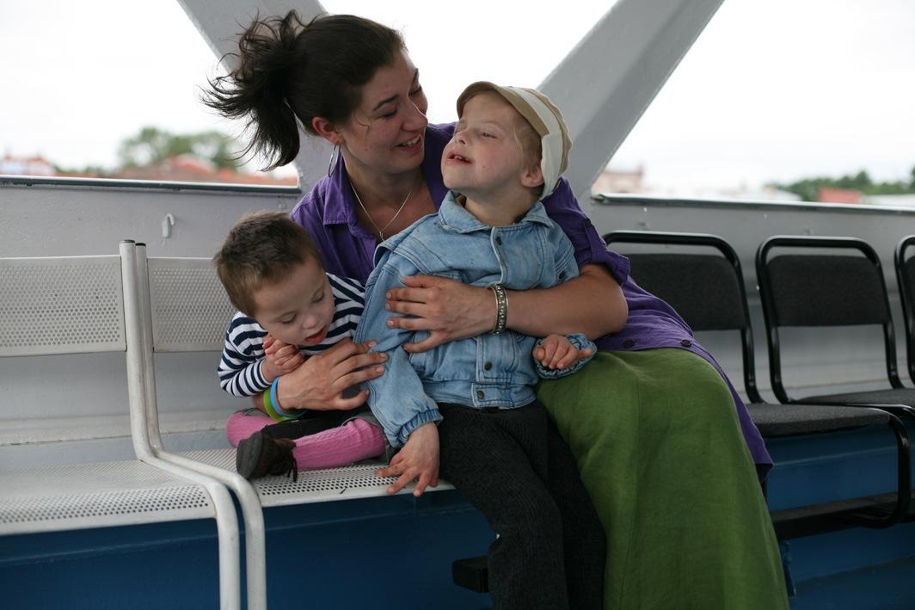
• helping the orphanage’s staff: for example a volunteer stays in a group and looks after kids while the nurse baths children, then help to get them dry and dress them,
• taking children to walks,
• looking after children for them to be clean and neat,
• plays educational games, learns numbers, letters etc.,
• having art classes (paint, pottery etc.)
• reading for children,
• accompanying children on excursions and camps,
• participation in preparation of different events.

PRACTICAL ARRANGEMENTS
- Volunteer needs a visa to enter Russia. According to Russian legislation, with humanitarian type of visa you can’t stay in Russia longer than 90 days. Therefore, after each 3 months of staying you will have a chance to go back home and see your friends and family while waiting for the new visa. Visa costs and travel are included into budget and these days at home won’t be considered as your holiday.
- You will have co-volunteers from different countries (up to 4 volunteers in total) and you’ll live together with them in a shared apartment.
- You will work up to 30 hours per week.
- You will have a local mentor who will help you to integrate better into local culture.
- You will receive 215 euro per month for food, transportation and pocket money.
- You will have language course of Russian language and strong medical insurance.
- You will have coordinator in hosting organization who will support you throughout whole project.
VOLUNTEER’S PROFILE?
- Open and ready for work with disabled people, experience is a plus. If you don’t have it, no problem, just be sure that you’re ready for it before applying.
- Age 18-30.
- Citizenship of one of the European union countries
- Basic knowledge of Russian and eagerness to learn.
- Enthusiasm and initiativness is something you won’t survive without in this project ;)
If you want to take part in this project, please send your CV and motivation letter form filled in by 11th of January 2018 to Evgenia at slav@shag-navstrechu.ru with topic “EVS in Shag navstrechu”. We will contact you shortly after that!
We hope that you will find our project interesting and you will apply for it – because you will get a chance to join wonderful and caring team, live in one of the best cities in the world and explore huge and mysterious Russia! ☺ If you want to get general impression about EVS projects all over Russia, read stories here, reasons to do your EVS in Russia are here. And some videos ;) First one you can find here and second one – here.

Looking forward to your applications!

