Project Description
European Solidarity Corps
ARSIS: Leontos Sofou 26, 54625, tel: +30 2310 526150,
mail: arsisvolunteers@gmail.com, http://www.arsis.gr/en/home/
Thessaloniki, Greeece September 2019- January 2020
Call for applicants

The volunteering activities of the programme will revolve around three axes:
a) recreational and educational activities with children and adults
b) integration and social assistance and welfare activities
c) communication and awareness raising activities
A) Recreational and educational activities with children and adults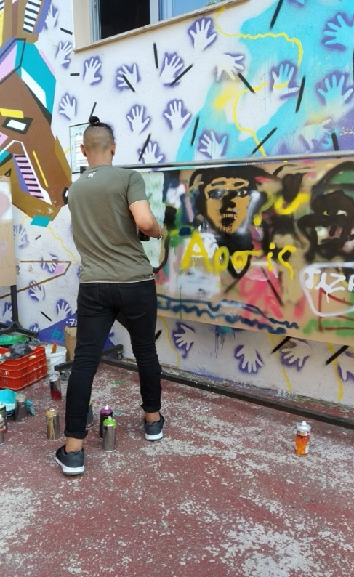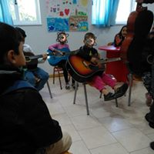
- recreational activities with children aged 0-18, such as music, theater, movie screenings
- school support classes for children and adolescents,
- language classes for children and adults
These activities will be facilitated in:
• ARSIS’ Youth Support Centers (YSCs)
• ARSIS’ Social Service for the Support of Vulnerable Social Groups
• ARSIS’ Accommodation Facilities for Minors at Risk and Unaccompanied Minors (UAMs)

B) Integration, social assistance and welfare activities
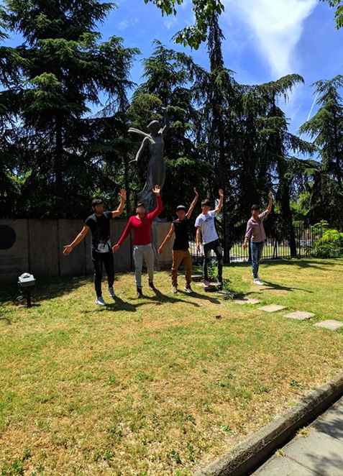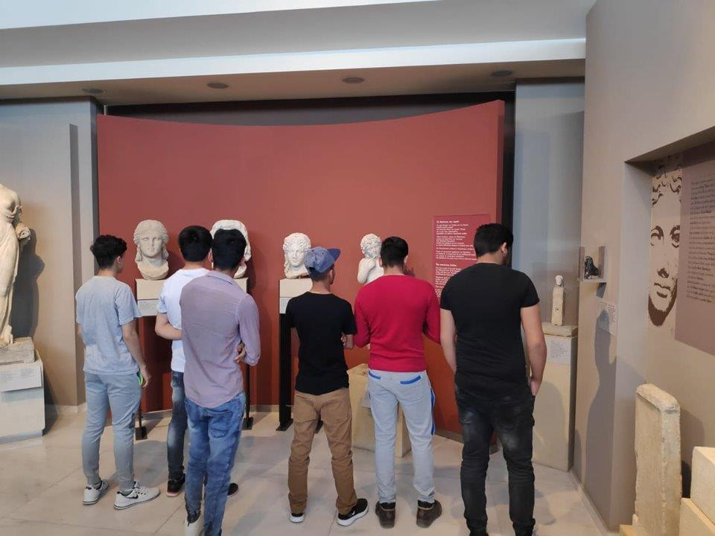
- participate in daily activities of accommodation facilities (care-taking or teaching children to keep
their personal space clean and tidy)
- escort children and adults to city-sites (cultural or sports events, visits in museums, etc)
- organize integration activities engaging local beneficiaries and the local population
- participate in the distribution of basic items top beneficiaries
- assist social workers or scientists in other psycho-social activities (mostly administrative support
such as giving information, record needs, etc)
These activities will be facilitated in:
• ARSIS’ Youth Support Centers (YSCs)
• ARSIS’ Social Service for the Support of Vulnerable Social Groups
• ARSIS’ Accommodation Facilities for Minors at Risk and Unaccompanied Minors (UAMs)
• The “SIN-praxis” Network of Collection and Distribution of first-need items for those in need
C) Communication and awareness raising activities
- organization of local communication and awareness raising events from an info-desk in a local square to a short social media campaign passing the message of one of ARSIS structures that they will volunteer
- participation in larger efforts that promote common values or present ARSIS to the main public, in collaboration with the Communication Department of ARSIS.
- taking an active role in “Solideers” communication and visibility activities
ARSIS is looking for motivated young people, willing to work and offer their experience and ideas to the organization and the greater community. It would be of great interest to the latter to involve people that share the EU's values on democracy, freedom, non-discrimination, and others, as well as ARSIS' beliefs on social inclusion, youth protection and equal treatment of all individuals. We particularly welcome people who see joining our team as an opportunity to work, and while cherishing their time with us, remain motivated to continue working even after the programme in the relevant field, back in their country or at any organization, wherever may be established. Participants ought to be people that work well within a team, evolve their team-spirit and co-working skills, yet manage to undertake individual tasks successfully, 6 volunteers from the 3 partner countries (Germany, Italy and
Romania) will be hosted for a period of 6 months.

